2021-2023 STRATEGIC PLAN

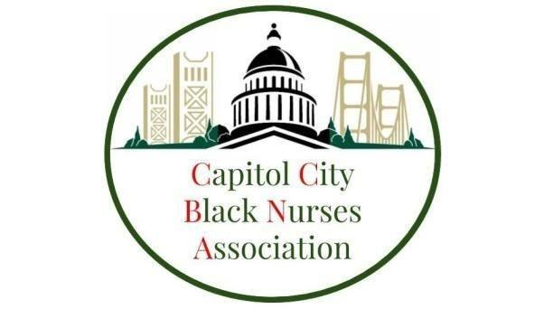

VISION
Create sustainable programs that improve allocation of opportunities for nurses, nursing students, and future generations of nurses through scholarship, accountability, and health equity.
MISSION
The Capitol City Black Nurses Association (CCBNA) aims to advocate for the needs of nurses and optimize health outcomes in communities where health disparities persist by promoting recruitment, retention, and enhancing the nursing education pipeline.
GOALS
- Build an active chapter membership that is engaged and motivated in community
- Lead and collaborate community programs directed at diversifying the nursing workforce
- Cultivate relationships among CCBNA and community organizations to increase knowledge, effectiveness and capacity for collective action
- Strengthen professional membership of membership
- Implement a fiscally responsible plan to sustain the ongoing development of CCBNA

YEAR 1
Goal 1: Build an active chapter membership that is engaged and motivated
Actions:
- Maintain documentation and accountability structure for membership contact and engagement status
- Hold regular membership engagement opportunities to build CCBNA relationships
- Hold at least 2 socially inclusive virtual or in-person events that are aimed a recruiting new member
Benchmarks:
- Grow membership by at least 20% over next 2 years
- Membership engagement surveys that demonstrate high marks in membership engagement and satisfaction
- Membership representation of all 5 large Sacramento Health Systems, majority of nursing schools and majority of public/community health organizations

Goal 2: Lead and collaborate in community programs directed at diversifying the nursing workforce

Actions:
- Establish collaborative relationships, contribute information, exchange ideas, and evaluate resources.
- Serve as expert consultants and provide health literacy guidance in health promotion programs
- Annual nursing diversity program that is sponsored by multiple local healthcare industries.
- Annual New Graduate Nurse professional development seminars
Benchmarks:
- Greater than 50% of CCBNA New Graduate students finding jobs within 6 months of receiving license.
- Successful conducting of an annual healthcare diversity conference

YEAR 2
Goal 3: Cultivate relationships among CCBNA and community organizations to increase knowledge, effectiveness and capacity for collective action.
Actions:
- Establish and leverage new and existing collaborative relationships, contribute information, exchange ideas, and evaluate resources.
- Facilitate opportunities for CCBNA to organize around nursing issues to increase influence on health outcomes.
- Advocate for critical issues that impact the Greater Sacramento Area.
- Expand the number of CCBNA volunteers and strengthen their role to build influence in the community.

Benchmarks:
- Identify and actively engage key stakeholders to establish ongoing relationships with community partners
- Identify opportunities to engage in annual events where CCBNA can attend and participate.
- Identify priority health initiatives pertinent to the Greater Sacramento area.
- Create CCBNA committees, increase visibility, and establish data collection methods to benchmark CCBNA outcomes.
Goal 4: Strengthen professional development of membership
Actions:
1. Educate CCBNA members about job performance and service as nurse leaders
2. Support CCBNA members in their career and academic advancement.
3. Promote an environment of learning, research, teamwork, communication and positive member morale through mentorship.
4. Collaborate with local colleges and organizations to anticipate and address the needs of the current and future nurses CCBNA members
Benchmarks:
  - Deliver education through in services, workshops, literature review, and expert lecture to CCBNA members.
  - Facilitate opportunities for CCBNA members to organize coalitions around issues or communities to increase their influence.
  - Foster a culture of mentorship and peer support amongst CCBNA members
  - Build and maintain a professional nursing network via organizational activities and involvement in CCBNA engagements.

Goal 5: Implement a financially responsible plan to sustain the ongoing development of CCBNA.
Actions:
- Maintain a current budget of all business accounts and active/potential projects
- Confirm financial priorities for 2021-2023 and create SMART goals for a financial plan
- Provide structure to the cash flow of business accounts that maximizes accounts payable and accounts receivable
- Efficient spending of donated funds that is aligned with CCBNA mission/vision
Benchmarks:
  - CCBNA Executive Board will prepare a simple budget and financial plan to sustain core ongoing activities.
  - CCBNA executive board will implement and monitor all accounts via accounting software capable with translating current trends in spending and tax reporting
  - Disseminate financial plan to all CCBNA Members on a Quarterly basis

About CCBNA’s Strategic Planning Process
CCBNA’s 2021-2023 strategic planning process began in May 2020 and included: executive board meetings and all member meetings.
The process was intentional about gathering information from a variety of sources and people that helped provide important insight into CCBNA’s future direction.
Strategic Planning Committee Members
Carter Todd, MS, RN, CCRN, President
Capitol City Black Nurses Association

Sheree Criner, MS, RN-BC, Vice President
Capitol City Black Nurses Association

Aron King BSN, RN, MS(c), Secretary
Capitol City Black Nurses Association

